
Lesson 9: On the Scoreboard
Unreal Engine (optional advanced track)
VIDEO GAME CREATION
This week: track a real score, and show it - along with your lives - on screen, all the time, not just at the end.
Open your own [YourName]Game project from Lesson 8 - don't start a new one.
Tip: no new assets this week - this is a logic and UI lesson.

Setup
- Open your [YourName]Game project from Lesson 8.
- Content Browser > Add > User Interface > Widget Blueprint, name it WBP_HUD. Open it and, in the Designer view, add two Text Blocks: ScoreText and LivesText, positioned in a top corner.
- In BP_GameManager - the placed Actor from Lesson 6 that already holds EnemiesRemaining and Lives - add a new Integer variable Score, default value 0.

Level 1 - Minimal (MVP)
Destroying an enemy adds 10 points to your score. Score and lives are both visible on screen, all the time, not just at the start or end of the game.
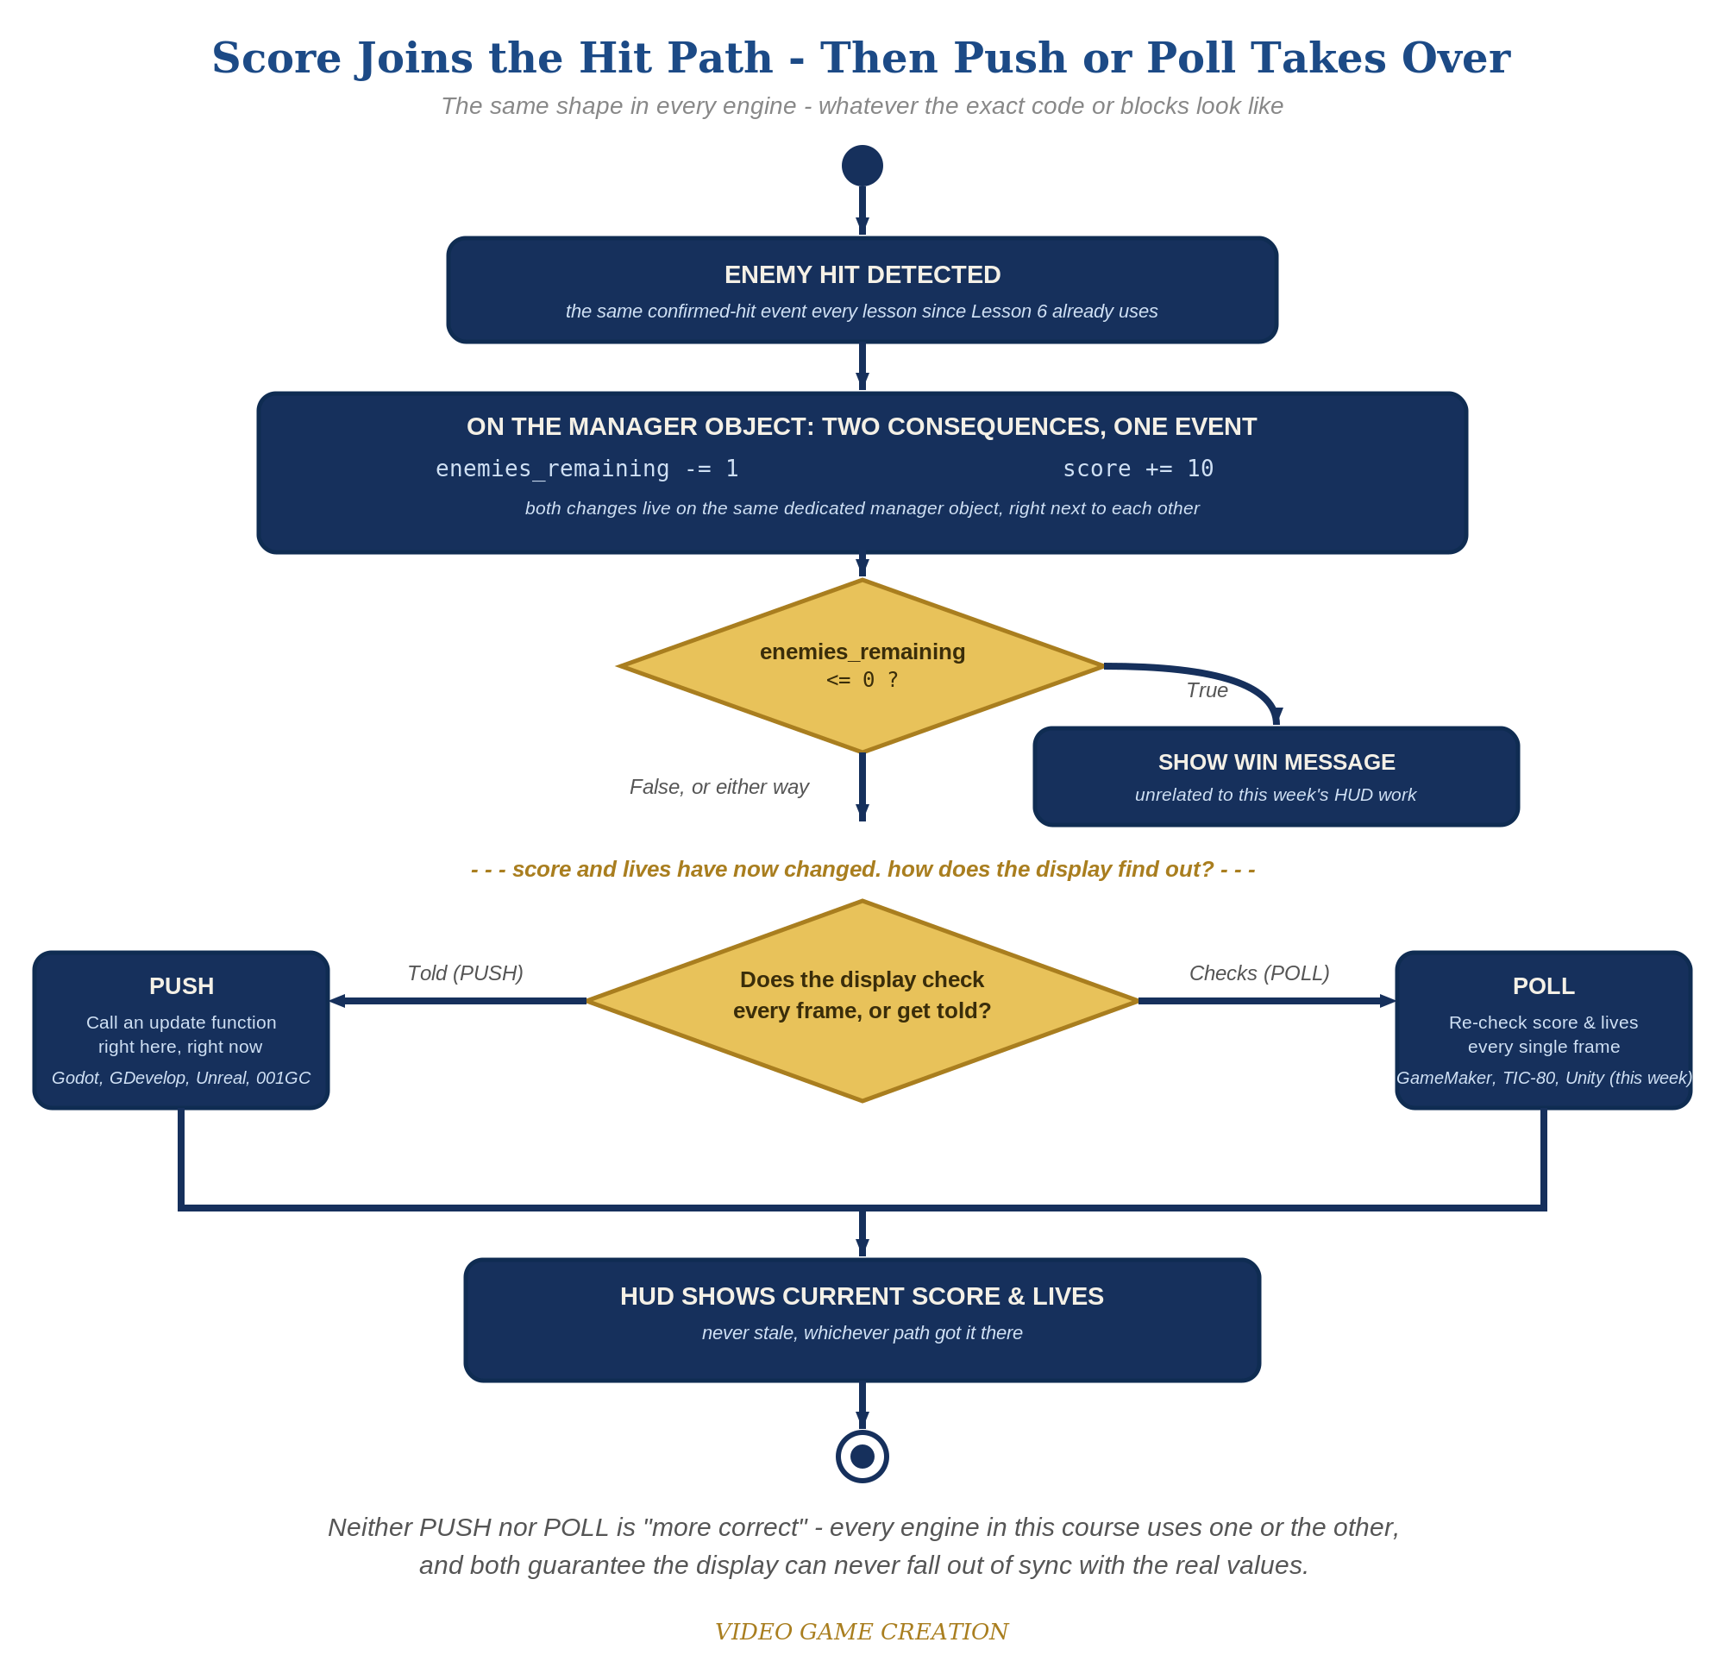
Score joins the hit path, then Push or Poll takes over - the same shape in every engine, whatever the exact code or blocks look like.
- In WBP_HUD's own Event Graph, add a Custom Event named UpdateHUD with two Integer inputs (Score, Lives), that sets both Text Blocks' text from those inputs (code below).
- In BP_GameManager, on Event BeginPlay, add "Create Widget" (Class = WBP_HUD) -> "Add to Viewport", and store the result in a new HUDWidget variable on BP_GameManager. Right after, call HUDWidget's UpdateHUD, passing Score and Lives, so the HUD shows correct starting values immediately.
- In BP_GameManager's existing HandleEnemyDestroyed, add Score = Score + 10 and call HUDWidget's UpdateHUD again. In BP_GameManager's existing HandleEnemyEscaped, call UpdateHUD again too, right after decreasing Lives.
- Click Compile, then Play, shoot a few enemies, and let one escape - both Text Blocks should update immediately every time.
Highlighted lines are new this week; everything else is code you already have.
WBP_HUD's Event Graph (new):
Custom Event UpdateHUD(Score: Integer, Lives: Integer) ->
Set Text(ScoreText, "Score: " + ToString(Score))
Set Text(LivesText, "Lives: " + ToString(Lives))
BP_GameManager:
Event BeginPlay (new) ->
Create Widget(Class = WBP_HUD) -> Add to Viewport -> Set HUDWidget
Call UpdateHUD(HUDWidget, Score, Lives)
Custom Event HandleEnemyDestroyed ->
EnemiesRemaining = EnemiesRemaining - 1
Score = Score + 10
Call UpdateHUD(HUDWidget, Score, Lives)
Branch(EnemiesRemaining <= 0) -> True: Print String("You Win!", Print to Screen = true)
Custom Event HandleEnemyEscaped ->
Lives = Lives - 1
Call UpdateHUD(HUDWidget, Score, Lives)
Branch(Lives <= 0) -> True: Print String("Game Over", Print to Screen = true)
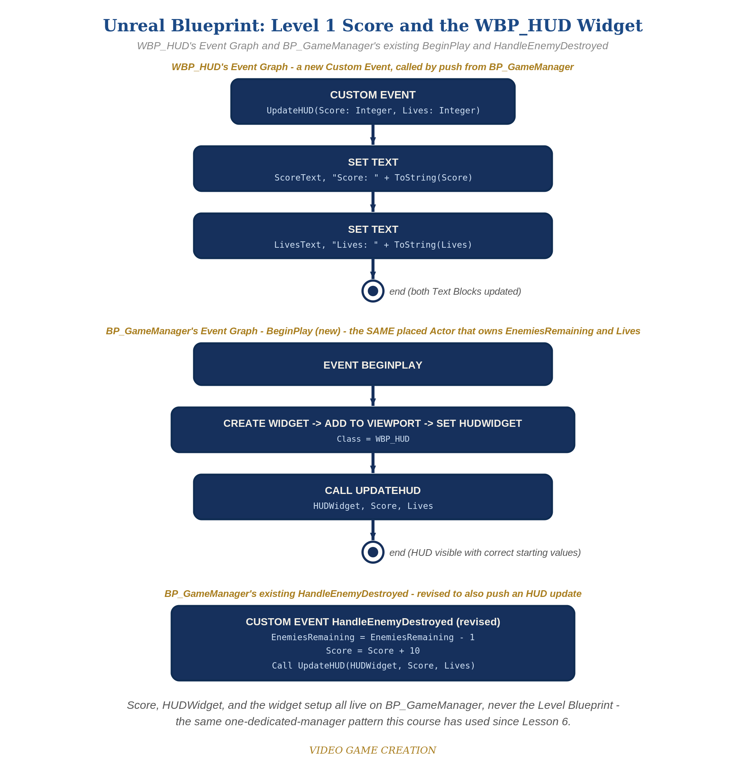
WBP_HUD's Event Graph and BP_GameManager's BeginPlay and HandleEnemyDestroyed - the node-for-node equivalent of the Level 1 code.

Alternate Path: C++ (code, optional advanced track)
The same push-based HUD pattern works in C++ instead of Blueprint nodes, calling into a UMG widget from game code.
- Create a UUserWidget subclass (e.g. UCppHUDWidget) with UPROPERTY(meta=(BindWidget)) UTextBlock* ScoreText and LivesText, and a function UpdateHUD(int32 Score, int32 Lives) that sets both texts.
- In your GameManager-equivalent C++ Actor class - the same class already holding EnemiesRemaining and Lives - create and add the widget once at BeginPlay, then call UpdateHUD() from the same places that already change Score and Lives.
This mirrors the Blueprint path's Custom Event exactly - same push-based shape, just from code.

Level 2 - Complete (Alpha/Beta)
The score and lives readouts never show a stale or wrong number - they always match reality, immediately.
- Shoot 3 enemies and confirm ScoreText reads exactly "Score: 30".
- Let an enemy escape and confirm ScoreText does NOT change - only LivesText should move.
- Confirm both Text Blocks show correct values the instant Play starts, not just after the first kill or escape (this is why UpdateHUD is called once right after Add to Viewport).

Level 3 - Refined (Ready to Publish) - pick any that interest you
- Visual: style the Text Blocks' font size/color in WBP_HUD's Designer view for a more game-like HUD look.
- Visual: change points-per-kill to a randomized value using a Random Integer in Range node.
- Structure: notice UpdateHUD is now the ONLY place that touches ScoreText or LivesText directly - BP_GameManager just changes numbers and calls UpdateHUD to reflect them, the same push-based pattern used in Godot this week, and the same one dedicated manager Actor that's owned all of this game's shared state since Lesson 6.

If Something's Wrong
- HUD never appears: confirm Create Widget and Add to Viewport both actually ran on BP_GameManager's BeginPlay (check that it's properly wired, not left disconnected).
- HUD shows "Score: 0" forever: confirm Call UpdateHUD is actually wired inside BP_GameManager's HandleEnemyDestroyed, not just defined in WBP_HUD and never invoked.
- Compile error on UpdateHUD: confirm the Custom Event's Score and Lives inputs are typed as Integer, matching BP_GameManager's variable types exactly.
- Score or HUDWidget not found: confirm Score, HUDWidget, EnemiesRemaining, and Lives are all variables on BP_GameManager - not accidentally created on the Level Blueprint instead.

Want More?
dev.epicgames.com/community/learning, Student Resource List > Unreal

